BB to create $500m green fund for textile
Star Business Report
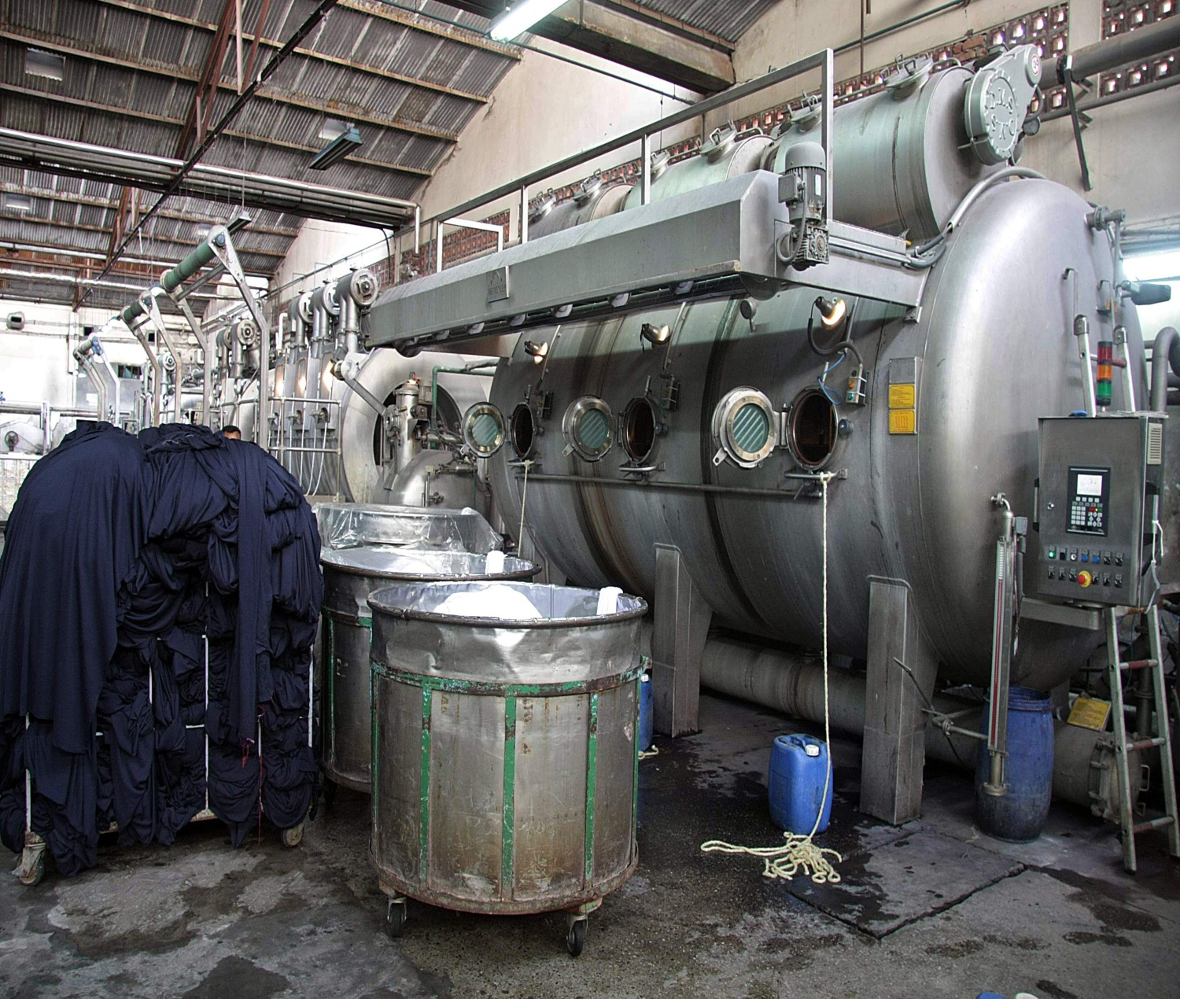
The central bank will set aside $500 million of low-cost funds for textile factories to help them adopt eco-friendly technologies and practices, Governor Atiur Rahman said yesterday.
The money will come in addition to the existing export development fund (EDF) of $1.5 billion and will be named Green EDF, he told a discussion at the office of Policy Research Institute of Bangladesh in Dhaka.
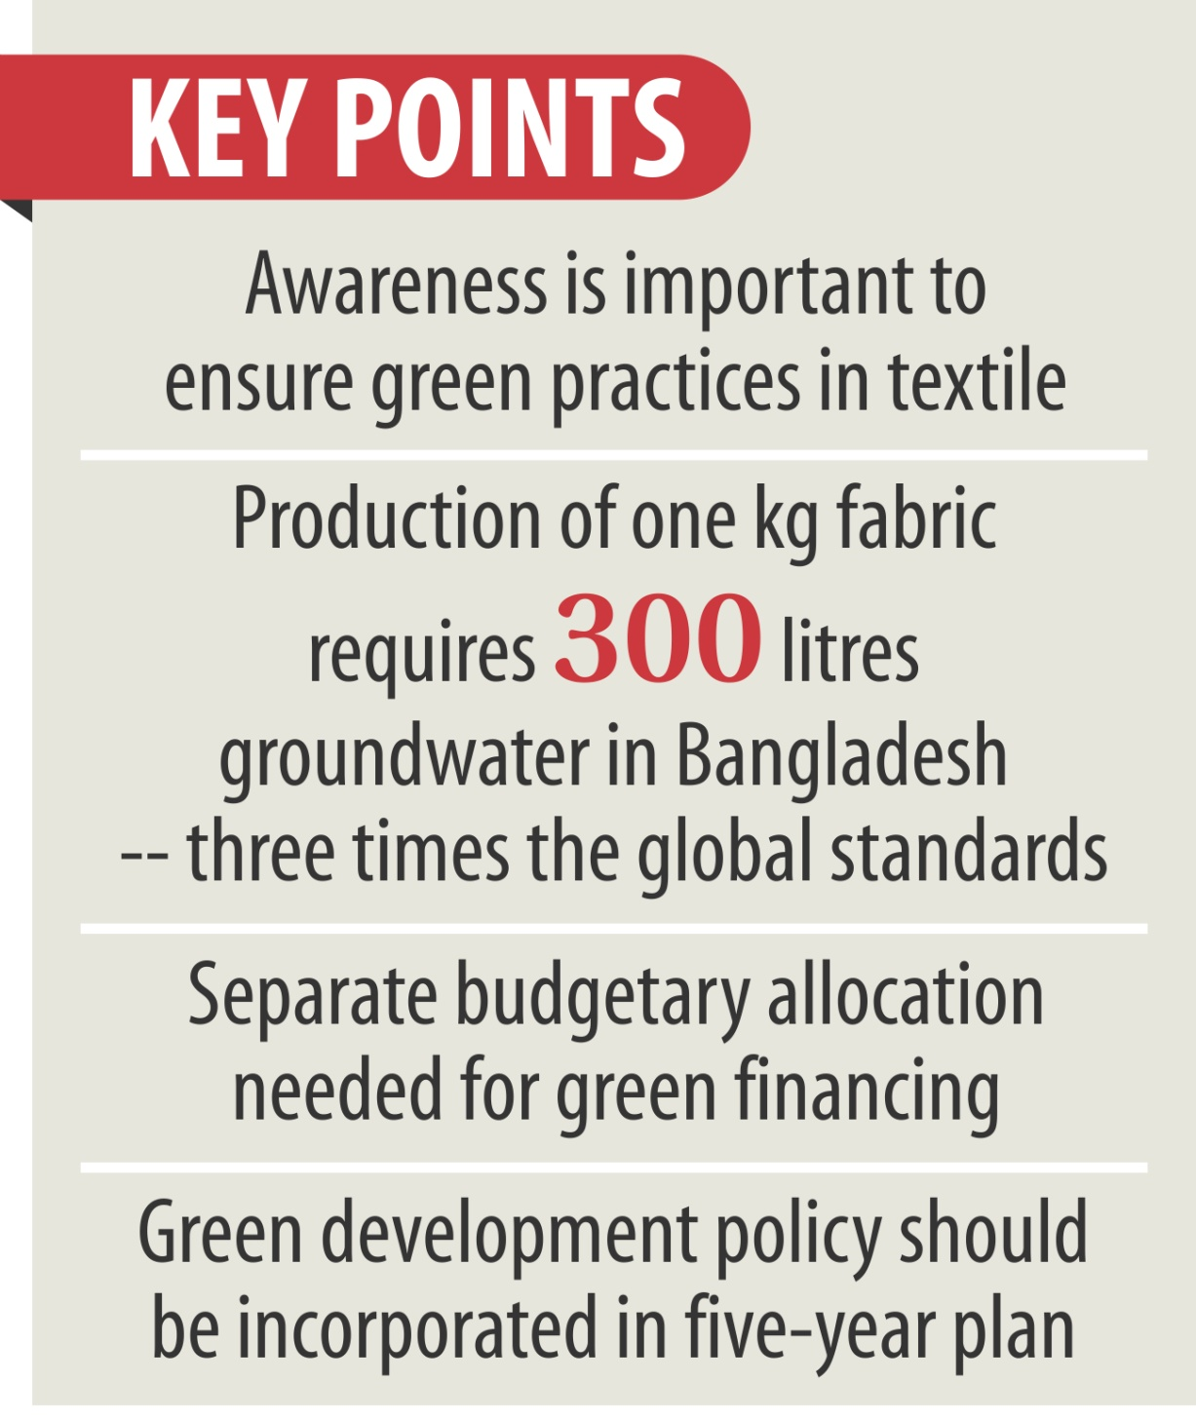
PRI organised the discussion on "access to finance: environmental sustainability in the textile sector" in association with the International Finance Corporation.
Rahman came up with the decision instantly after a number of bankers and economists stressed the need for such a fund for the textile sector.
At present, Bangladesh Bank is offering the EDF to exporters at a rate of LIBOR (London Interbank Offered Rate) plus 2.5 percent for six months. An exporter can borrow a maximum of $15 million in foreign currency.
"The criteria for accessing the fund by the wet processing units, which are also export-oriented or providing supplies to the garment sector, should be considered in view of the overall sustainability of the textile sector," said Ahsan H Mansur, executive director of PRI.
At the seminar, he presented a paper, which he prepared in association with Ifty Islam, managing partner of AT Capital.
Advertisement
Mansur said inefficient resource use and poor environmental practices are major challenges for the textile sector. The textile factories in Dhaka currently consume 1,500 billion litres of groundwater annually to produce five million tonnes of fabric, with every kg of fabric gobbling up 300 litres against the global standard of 100 litres per kg of fabric.
Mansur said making funds available does not guarantee that entrepreneurs would use the resources.
"Education and awareness is important. Besides, customs and supplementary duties should be eliminated for importing cleaner technology equipment and machinery."
The BB governor said the country's garment sector would not be able to reach the $50 billion export target by 2021 without adopting green technologies.
Rahman called for a separate allocation in the budget to promote green financing in the textile sector. "Budgetary allocation makes it possible to provide low-cost funds."
The BB chief said the progress in the textile sector has also brought in multiple challenges in urban expansion, land use, workplace safety and environmental safeguards.
For example, textile dyeing and finishing units in Bangladesh are known to be hugely wasteful in water usage as they consume five times the best practice benchmark.
The toxic discharges of the industry pollute both surface and ground water which has serious consequences for all living beings.
"Long-term sustainability of the industry greatly lies in its ability to produce green textile products mainly due to growing consumer demand for eco-friendly products," the governor said.
Rahman also said a green development policy should be incorporated into the next five-year plan of the country.
Mohammed Abdul Jabbar, managing director of DBL Group, said with an initial investment of $100,000, his company was able to reduce wastage of water, energy, steam, dye and chemical worth $500,000 within a year. "So, it is a matter of mindset. It is not a big deal."
Mustafizur Rahman, executive director of Centre for Policy Dialogue, said environmental sustainability is very important for the country's mid- and long-term development.
"The country will be able to raise its garment exports to $50 billion by 2021 if the factories are eco-friendly."
Ifty Islam said environmental sustainability has become a central point of China's five-year plan although the country is infamous for environmental pollution. "We will have to do the same."
Faruque Hassan, a former vice president of Bangladesh Garment Manu-facturers and Exporters Association, said the factories need financial support from the government and price support from buyers to go for eco-friendly practices.
Abrar Anwar, chief executive officer of Standard Chartered Bangladesh, said financing would not be available for factories if they are not eco-friendly.
Mamun Rashid, chairman of Financial Excellence Ltd, and Mrinal Sircar, programme manager of Bangladesh Water PaCT, also spoke.

Published: 12:00 am Sunday, February 15, 2015
Last modified: 12:13 am Sunday, February 15, 2015

http://www.thedailystar.net/business/bb-to-create-500m-green-fund-for-textile-64793
BB to create $500m fund for green industries
Atiur for separate allocation in budget from next fiscal
FE Report
The Bangladesh Bank (BB) will soon develop a new Export Development Fund (EDF) worth about US$ 500 million to support environment-friendly industrial and development projects.
BB Governor Dr Atiur Rahman disclosed this while addressing a seminar on 'Access to Finance - Environmental Sustainability in the Textiles Sector' in Dhaka on Saturday. He asked concerned officials to implement the instructions accordingly.
Addressing the seminar, organised by a private think-tank -- Policy Research Institute (PRI) of Bangladesh-the central bank governor expressed the hope that the country's mainstream banking system would soon be transformed into Green Banking which, he said, would unlock new opportunities and spur business activities.
"To achieve US$50 billion RMG export by the year 2021, there is no alternative to environment-friendly industries," said the governor urging banks and non-bank financial institutions to finance more projects that promote green initiatives.
The whole world, including India, the governor said, has now concentrated more on green technologies and is making budgetary provisions to promote eco-friendly industries. But, he lamented, Bangladesh is yet to take any initiatives in this regard.
He urged the government to make budgetary allocation from the next fiscal and incorporate the issue into the ensuing Seventh 5-year Plan to promote green industries.
"There should be separate allocation in the budget for green financing," said the governor.
In the backdrop of local entrepreneurs' demand for enhanced financial support to meet environmental compliance as per global market requirement, the central bank has come up with the new initiative to introduce the new EDF.
"Entrepreneurs who want to invest in eco-friendly
Continued to page 7 Col. 1

Continued from page 1 col. 8
industries will get assistance from the fund. Small enterprises from leather and RMG sector may utilise it," said the governor.
The BB has so far identified 47 green products under the refinance scheme with addition of three new ones, including the garment sector.
"All financial institutions have been directed to allocate at least 5 per cent of their loanable funds to green finance by the year 2016," said the governor.
He said the BB has remained proactive in lining up policy support, both on its own and also in cooperation with the government and the development partners. The central bank supports lending for installation of Effluent Treatment Plants (ETPs) in textiles dyeing and finishing establishments.
The PRI organised the seminar in collaboration with the IFC to find out ways and means how to turn textile and RMG industries, a major contributor to water pollution, into an eco-friendly industry by addressing the challenges, ensuring safety issues and improving environmental efficiencies.
A large number of entrepreneurs, economists, researchers, bankers and environment activists attended the seminar.
Held at the PRI conference room, the seminar was addressed among others by Bangladesh Water Pact Programme Manager Mrinal Sircar, Centre for Policy Dialogue (CPD) executive director Dr Mustafizur Rahman, Standard Chartered Bank CEO Abrar A Anwar, chairman of Financial Excellence Limited Mamun Rashid, former BGMEA vice president Faruque Hassan and Business Initiative Leading Development (BUILD) CEO Ferdaus Ara Begum.
PRI executive director Dr Ahsan H Mansur presented the keynote paper on the subject.
According to Dr Mansur, the industry is now at a crucial juncture. Several outstanding structural deficiencies have been brought under the spotlight following a series of recent tragic incidents like Rana Plaza building collapse and Tazreen fire.
To overcome the problems, he said, the Bangladesh Bank could extend various credit lines for green investments to encourage the polluting industries to adopt more environment-friendly processing facilities and inputs.
To make the RMG sector more compliant and environment-friendly, speakers at the meeting urged the government to eliminate customs, supplementary and regulatory duties in case of importing environment-friendly, cleaner technology equipments and machineries.
Dr Mustafizur Rahman in his speech highlighted the urgency for extending necessary financial help to small and medium enterprises (SMEs) which are confronting a lot of problems to make those more efficient and compliant both technically and environmentally.
"Efficiency leads to higher productivity," he said.
To make the Export Development Fund more effective, Dr Mamun Rashid suggested modification of the fund, extension of its time limit and increase in the size of the fund. He also felt that there should be political commitment to ensure viable use of the fund.
mzrbd@yahoo.com
http://www.thefinancialexpress-bd.com/2015/02/15/81296

