Exports show a silver lining in gloom
Refayet Ullah Mirdha
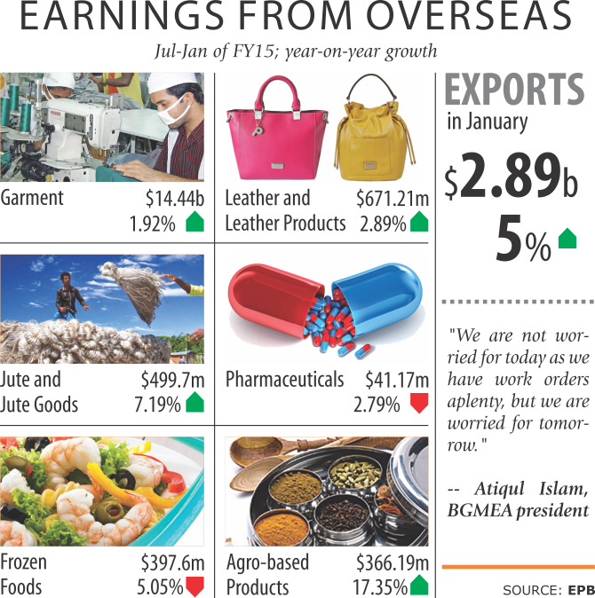
January's export figures delivered a ray of sunshine amid the doom and gloom brought about by the dragging political turmoil, registering positive growth in keeping with the uptick generated last quarter.
Last month, exports grew about 5 percent to $2.89 billion year-on-year, according to Export Promotion Bureau. The figure is also higher, albeit slightly, than in the previous month: in December last year, some $2.84 billion was received.
January's takings missed the export target for the month, which was $2.97 billion.
Garment products, which typically account for more than 80 percent of the export earnings, also saw an increase. In January, garment exports fetched $2.42 billion, up about 8 percent year-on-year and 3.86 percent month-on-month.
“We now have splendid export growth despite odds like Rana Plaza building collapse and Tazreen fire due to our aggressive marketing campaign. But our exports will stutter if the political upheaval goes on and on,” Atiqul Islam, president of Bangladesh Garment Manufacturers and Exporters Association, said.
“We are not worried for today as we have work orders aplenty, but we are worried for tomorrow.”
He said the international retailers have already started retreating.
Advertisement
They are not coming to Bangladesh to place orders for fear of getting caught in the violence, instead asking the factory owners to meet in a third country.
And even then, they are not placing the full volume of orders: the retailers are putting in 50 percent of the orders now, as they think the garment makers would not be able to execute the whole order timely due to the production disruptions brought about by the political crisis.
The retailers say they are adopting a 'wait-and-see' policy, sitting back for developments -- one way or the other -- on the political deadlock.
Meanwhile, representatives of 65 international retailers, who altogether account for 88 percent of the export orders, have demanded an immediate solution to the current crisis and an uninterrupted supply chain between Dhaka and Chittagong at the regular buyers' forum on Monday.
Published: 12:00 am Thursday, February 05, 2015
Last modified: 11:56 pm Wednesday, February 04, 2015
http://www.thedailystar.net/business/exports-show-a-silver-lining-in-gloom-63277

